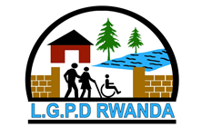
THE LIFE GATE FOR PERSONS WITH DISABILITIES
IREMBO RY’UBUZIMA KU BANTU BAFITE UBUMUGA
“Sharing Hope, advocate and Transform broken lives”
Contact : +250788474811 Email: Lifegaterwanda21@gmail.com

SUCCESS STORIES FOR THE YEAR 2024

Through the DRF grant to LGPD in 2024, the following key project impacts have been highlighted by beneficiaries:

N. Monique, a mother of three children and a woman with a physical disability, shared her inspiring journey. Before joining LGPD, she wasn’t aware of her rights and felt afraid, due to hurtful treatment from her family and society. But after attending UNCRPD trainings funded by DRF, she learned that she, too, had rights and was capable.

When she first joined LGPD, she felt ashamed and upset about her disability, recalling how neighbours had mistreated her. She didn’t feel valuable, but LGPD helped her realize her worth.
Through the trainings, Monique gained new skills about the rights of PWDs and feel confident. She now participates in community works (once a month), participate in decision-making, advocating for children and girls with disabilities who are hidden away at home. She works with her local authorities to challenge negative societal perceptions against persons with disabilities.
Monique now looks to her future with hope. The training gave her direction and taught her how to seize opportunities and grow. She believes in herself and knows that tomorrow is brighter, because she is capable, too.

Francine, a blind woman, expresses her gratitude to DRF through its fund to the Life Gate for Persons with Disabilities for helping her get healthier, transformed life through skills and confidence gained from empowerment programs. Before receiving UNCRPD training on women’s rights, she felt hopeless, and society, as well as family, tortured her due to her blindness, which her life become hampered. But after attending training sessions, her life quickly changed. She began to feel capable and empowered to improve her life situation.

With determination, Francine worked hard to create job opportunities for herself and enrolled in courses of massage to develop new skills. She now practices kinesiotherapy (massage therapy) to support her family. Francine encourages other people with disabilities not to lose hope, reminding them that disability is not inability: they are capable of achieving great things.
She urges society to have faith in people with disabilities and hire them, as many are often overlooked due to misconceptions about their abilities. She is also thankful to disability’s groups and organizations for advocating for the rights of people with disabilities and asking the employers to consider individuals with disabilities, believing that they can too contribute and succeed.

Chantal, a mother of Benita, a girl with a physical disability, shares her journey of transformation through DRF’s training via LGPD. Before receiving the training on UNCRPD, Chantal felt ashamed of her daughter’s disability and faced mockery from family and neighbors. But after learning about the rights of people with disabilities, especially children, she embraced her daughter’s needs and love her fully.

With the new knowledge, Chantal took charge of her daughter’s health, reaching out to healthcare providers. Benita eventually received surgery and is now healed, walking confidently and is now attending school with other children at her age.

Chantal, along with other parents of children with disabilities, expresses gratitude to DRF for funding the LGPD to empower them through the rights of people with disabilities. The training has helped them love themselves, build confidence, and envision a brighter future.

Celestin, the father of Patrick, a child with a physical disability (clubfoot), shares his heartfelt journey. He admits it was difficult at first to accept having a child with a disability. Before learning about LGPD, he felt ashamed of his son. However, after receiving training on the UNCRPD, Celestin gained the knowledge and confidence to love his child fully.
Through LGPD’s advocacy and collaboration with other disability organizations, Celestin was encouraged to seek further medical treatment for Patrick. Today, his son is receiving surgery at Rilima Hospital.

Celestin has overcome the negative comments from others about people with disabilities and their families. He now actively encourages other parents not to isolate their children or feel ashamed of them. He believes that children with disabilities are just as capable and deserving of love and care as any other child.

He is deeply grateful to DRF and LGPD for the trainings, which helped him understand the rights of people with disabilities and realize that he should be proud of his son and seek further to respect his chirld's rights.

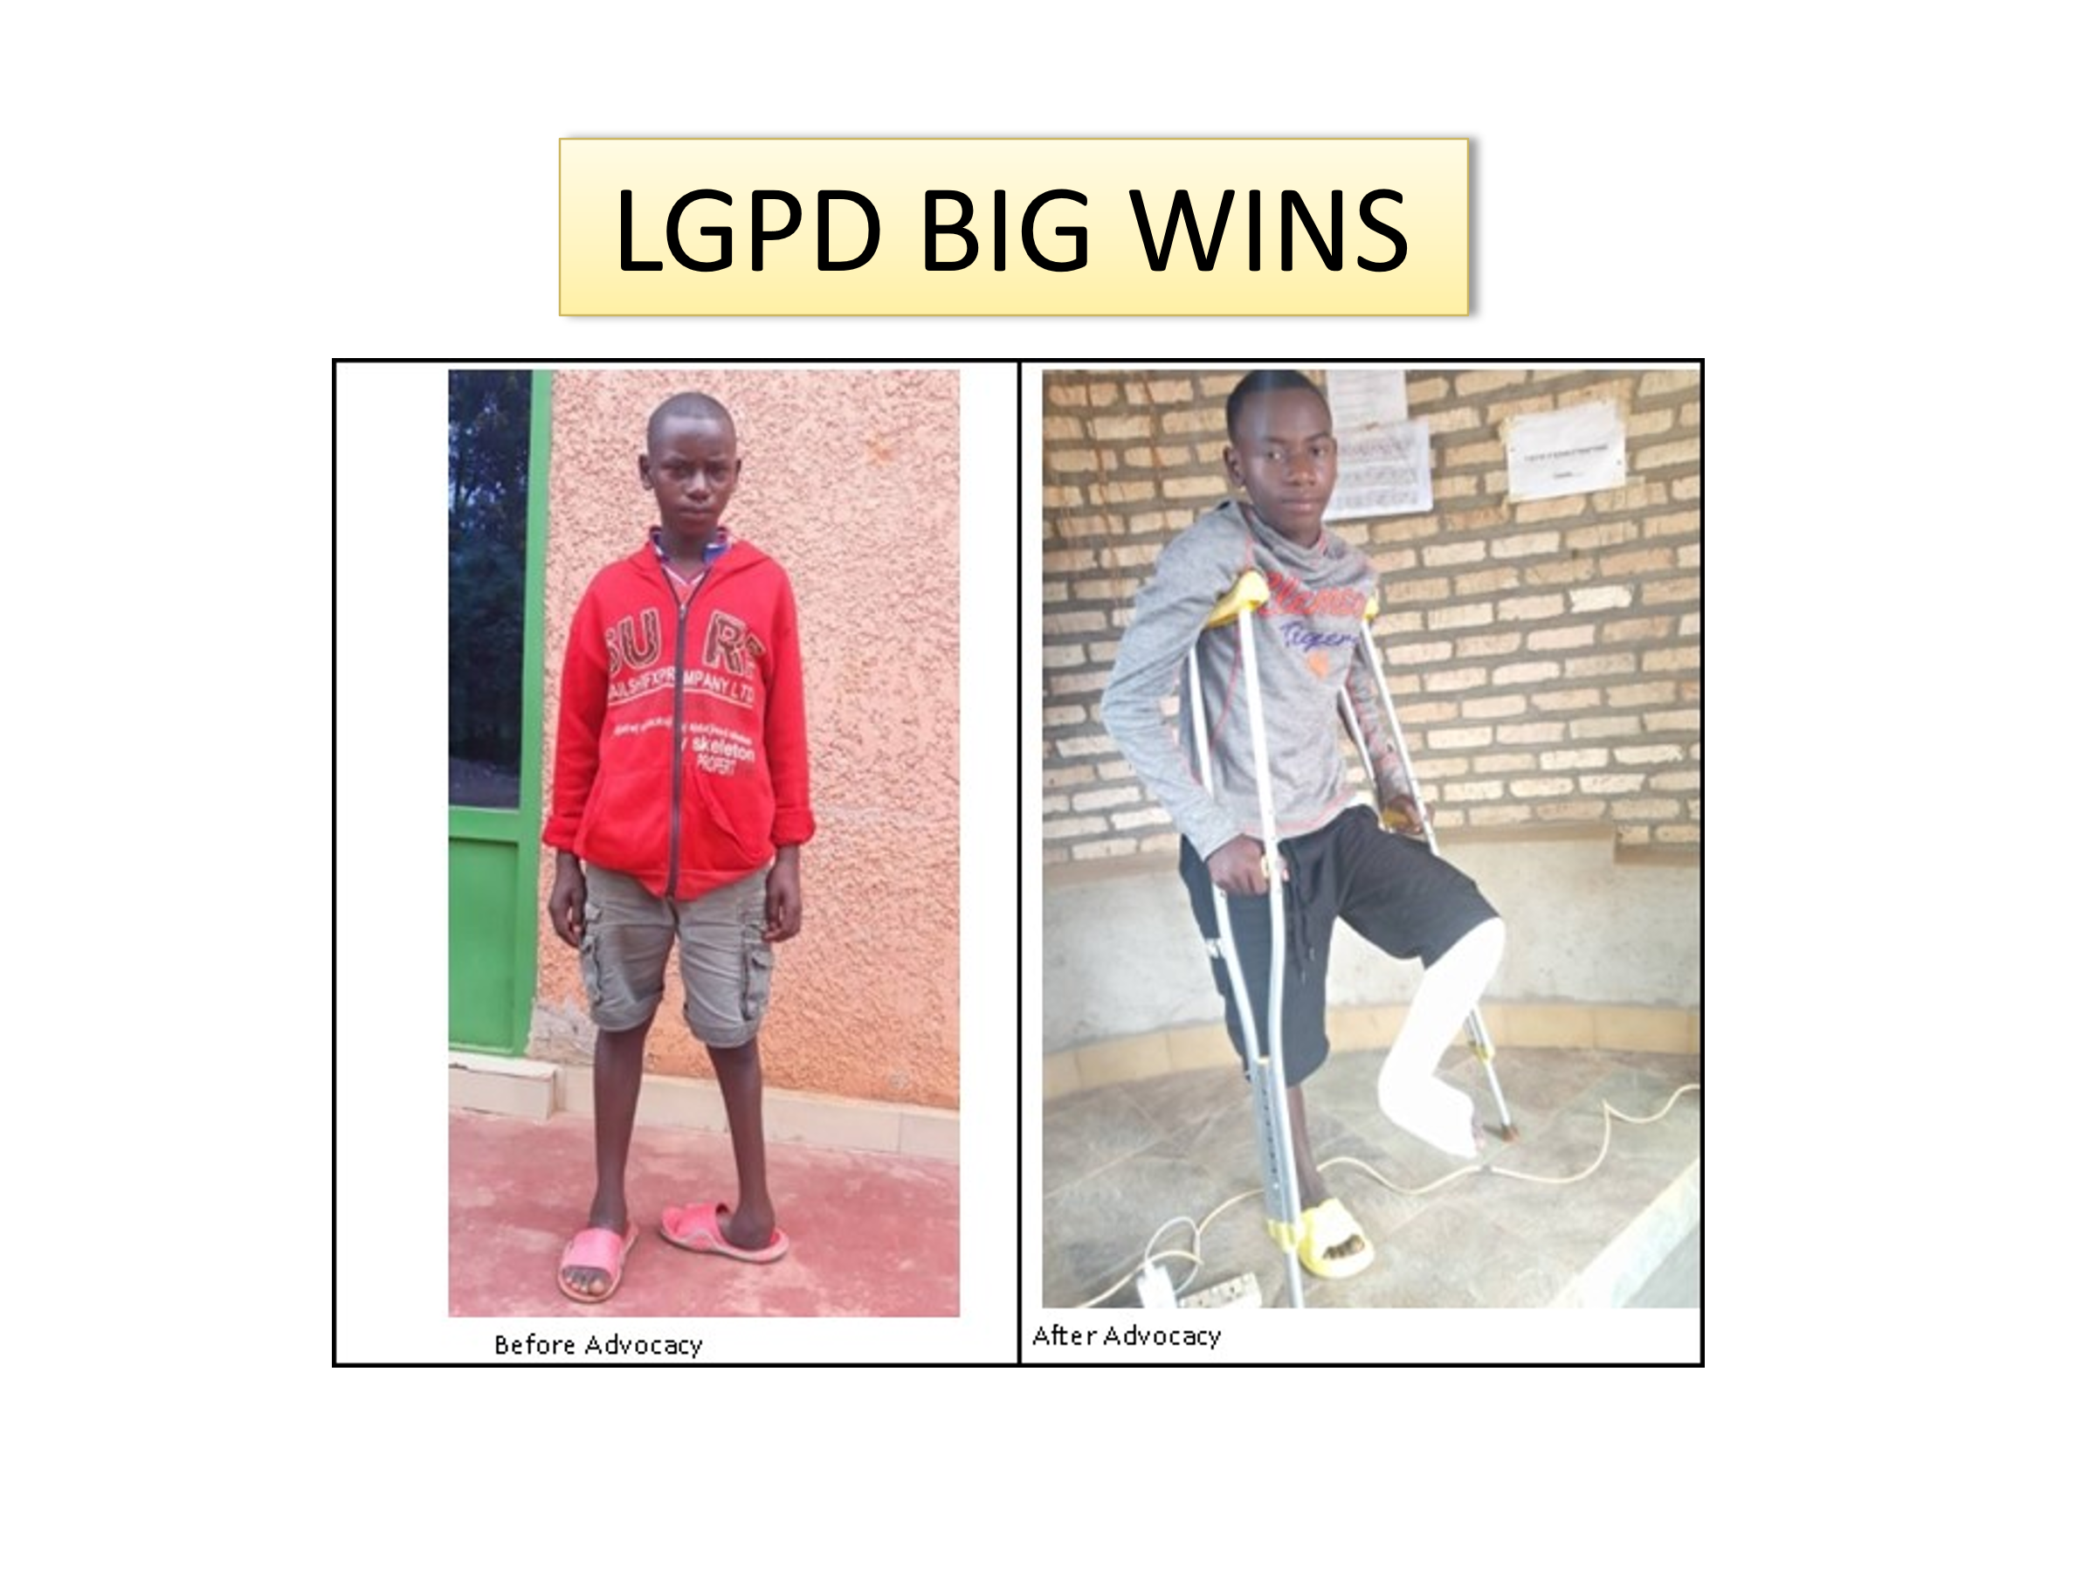
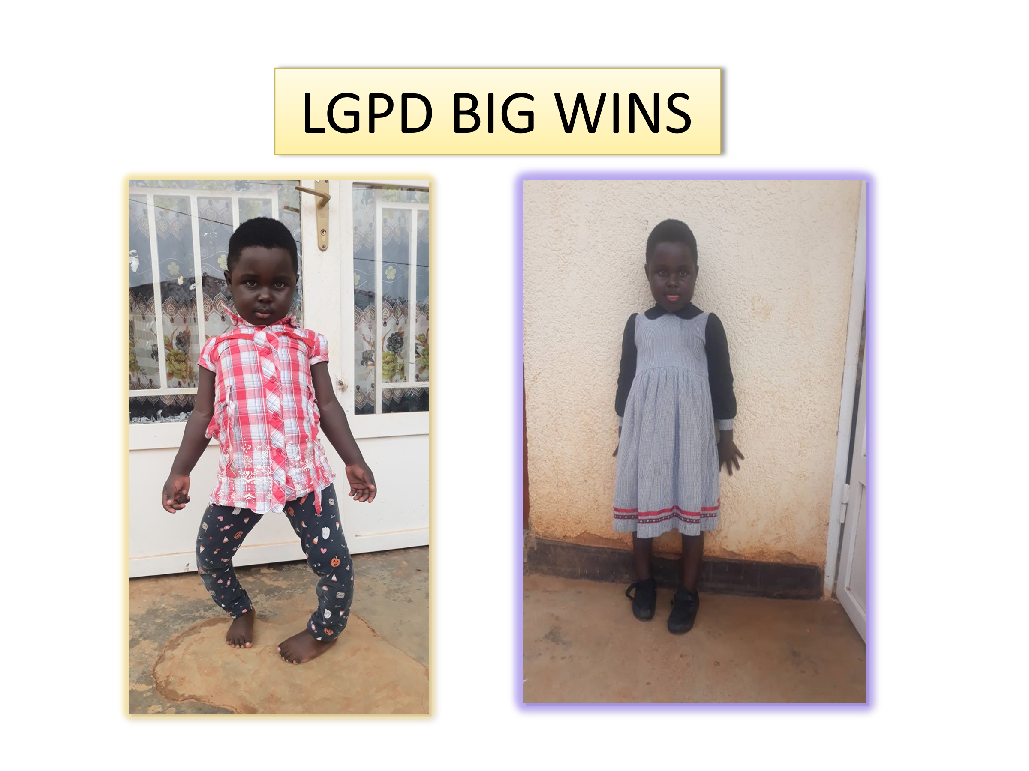

Done at Ndera, on 20 January 2025

